1)Inheritance:

* It is a process in which a sub-class(child class) acquires all the properties of superclass(Parent class).
* Child class acquires the properties from parent class by using “EXTENDS” Keyword.
* There are 5 types of inheritance,
  + Single Inheritance: Here one parent class and one child class, where single child class extends single parent class.(as shown in fig a)
  + Multi-level Inheritance: Here one parent class and child class and sub child class, where child class extends from parent class and sub-child class extends from child class, .(as shown in fig b)
  + Heirarchical Inheritnace:Here one parent class and more than one child classes extends the properties from single parent class, .(as shown in fig c)
  + Multiple inheritance:Here multiple parent class and single child class extending from more than one parent classes, .(as shown in fig d)
  + Hybrid Inheritnace:It is a combination of hierarchical and multiple inheritance,here ambiguity problem occurs.(as shown in fig e)
  + Multiple and Heirarchical inheritance is not supported by classes in java,it is supported only in interface. .(as shown in fig d and e)

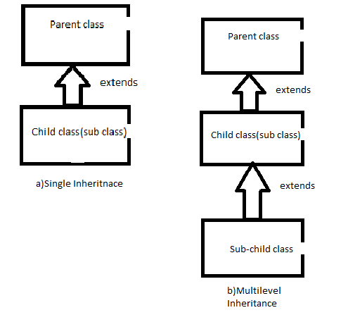

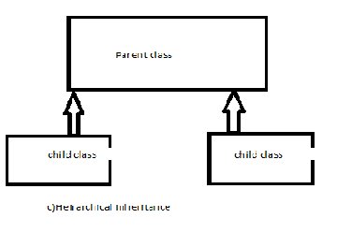

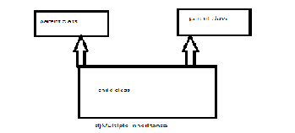

2)Polymorphism:It is a process where a single action or task can be performed in manyways.

The word “POLYMORPHISM” is taken from greek,”poly” means many and “morphism” means forms.

It has 2 types:

* Compile Time polymorphism:It is also known as early or static binding,the best example for this is “Method overloading”,
* Runtime time polymorphism: It is also known as late or dynamic binding,the best example for this is “Method overriding”,

Method overloading:

A class contains multiple methods of same type and same numbers is called as method overloading,

* Here the method name should be same with same type and numbers of parameters.
* The main advantage is code readability is achived.

Example:

class addition{

int add(int a,int b)

implementation

}

int add(int d,int e){

implementation

}

Method Overriding:

For method overriding Inheritance (IS-A Relationship) is must,the relational classes having same type of method signature is method method overriding.

* In this the method signature must be same with same number and type of parametrers,but different implementation.
* The main advantage is code reusabiltiy is achived.

Class Animal{

Void sound{

System.out.println(“all sounds of animals”)

}

}

Class Dog{

Void dog{

System.out.println(“bark bark”)

}

}

3)Abstraction:

The process of hiding the implementation and providing only the functionality of the code is known as abstraction.

There are certain rules to achieve abstraction,

* If the class should be called as abstract then it should be declared with “ABSTRACT” keyword,
* The abstract classes can have both abstract and concrete methods,
* If any class has abstract method in it then the class must be declared with “ABSTRACT” keyword to make the class as abstract class,
* Any method can be made abstract by declaring it with abstract keyword,
* Abstraction can be achieved from 0 to 100%.
* The main advantage of abstraction is,if any future enhancement or changes can be done without affecting the user,

The best example for abstraction is desigining a motor bike by two companies,

Abstract Class hero{

Void engine(){

System.out.println(“engine is designed by hero”);

}

Abstract Void body(){

}

Class Honda{

Void engine(){

System.out.println(“engine is designed by hero”);

}

Void body(){

System.out.println(“Body is designed by Honda”) (providing honda’s own implementation without effecting hero’s methodand its implementation)

}

}

4)Encapsulation:

It is a process of wrapping the code and data together into a single unit is known as encapsulation.

* We can create a fully encapsulated class in Java by making all the data members of the class private,
* There are cerytain advantages of encapsulation,
  + By using getter and setter method we can make the code READ-ONLY (OR) WRITE-ONLY,
  + It provides us to control the flow of data,
  + It is easy,simple and fast,
  + It is also used to hide the data from other classes by making it as private.

Example:

Public Class employee{

Private string name;//making the data as private,

Public string getName(){

return name;

}

public void setName(String name){

this.name=name;

}//by using getter and setter making code READ ONLY OR WRITE ONLY.

}

2)JDBC(Java database connectivity):

It is An API which is used to build a connection between java application and the database server to achieve loose coupling.

There are few steps to build a connection between JDBC and database servers with the help of JDBC drivers,

JDBC Drivers are nothing but the implementation of JDBC API,the Driver is an interface which contains certain implemented class in the form jar files.

Steps to build connection:

1)Load and register Driver class:

The driver class can be loaded and registered in two ways,

1)by creating the object of driver and using the method registerDriver(),

2)by using static method class.forName(Driver)

It is suggested to and good practice to use static method for registering and laoding the class.

Class.forName throws an classNotFound execption which must be handled using try-catch block.

2)Build a connection:

The connection can be build by using getConnection() method,

The return type of getConnection() is connection interface, getconnection is the helper method of connection interface to create an implementation object of connection interface,

3)Create Statements or platforms:

There are 3 types of statements to build/create statements;

1)Statement:it is an interface which is used whose implementation object is created by a helpermethod called createStatement() method connection interface,the return type of this method is statement interface.

2)Prepared Statement:It is an subinterface of statement interface whose implementation object is created by a helpermethod called createStatement() method connection interface,it supports the concept of placeholders, Placeholders are used to set dynamic values by users,

3)callable statement: It is an subinterface of preparedStatement interface,it supports the concept IN and OUT Parameter of stored procedures.

4)Execute Query:

There are 3 methods to execute the queries:

1)execute():it use dt o execute all the DDL,DQL and DML statements,it returns true for DQL statement if the the condition is satisfied and returns false in case of DDL and DML.its return type is Boolean,

2)executeUpdate():it is used to execute only DML statements ,its return type is resultSet,the data which is fetched fro the database is stroed int cursor and fro cursor it is mapped into resultSet,resultSet is the exact mapping of data present in database,

3)executeQuery():The DQL statements are executed by using this method,its return type is integer,if the data if updated or delted it eturns 1 or else 0.

5)close connection:All the costly resources must be close it is good practice,if we use try with resources it auto closes the connection.

3)Execption:

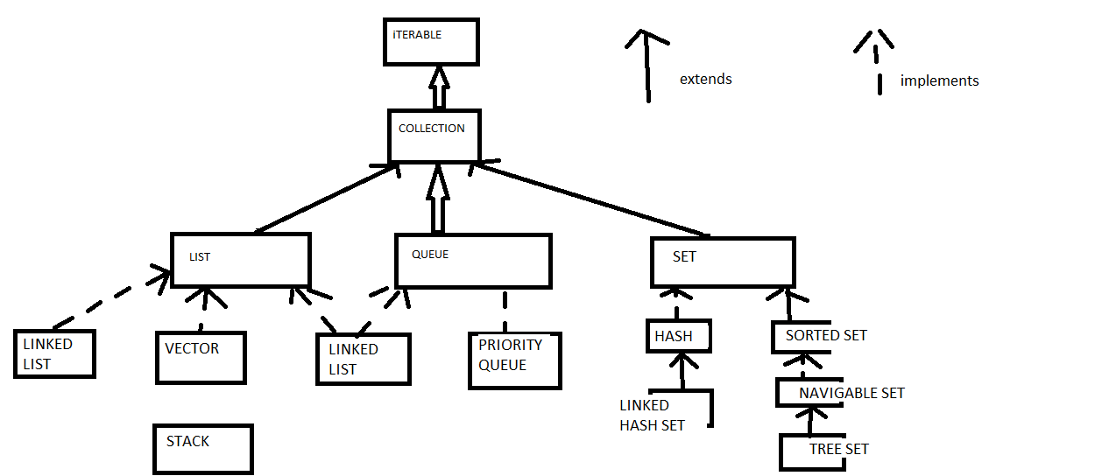

Collection:It represents group of individual object as a single entity.

Collection framework:

It is a group or collection of interfaces and classes which represents a group of individual object as a single entity.

The top most interface of collection is iterable which is extended by colletion interface,which then extended by 3 interfaces called as LIST,QUEUE,SET.

The implementation classes of interfaces are:

1)LinkedList: it is one of the implementation class of List interface,as list has two types sequential and non sequential lits,linked list comes under non sequential list,it supports both list and queue functionalities,

The underlined data structure of linked list is doubly linked list,

In this insertion order is preserved,

null values are allowed,

duplicates are allowed and

insertion is indexed based,

It implemenets maker inertfaces like serizlizable and clonable.

It stores the lemenets in the form of nodes and it doesnot have any initial capacity and only one default constructor is present in this,

It enques and deques from front or rear end in queue.

2)Hash Map:

In Hash map the elements are stored in unique order in the form of key-value pair,where key is the hashcode of object and value is the object itself.

The key property doesnot allow the duplicate insertion of elements ,

In this, insertion order is not preserved,

Duplicates are not allowed, and

Only one null value is allowed,

The underline datatstructure of hashmap is Hash table,

It implemenets maker inertfaces like serizlizable and clonable.

3)Tree Set:

Tree set is the implementation class of navigable interface which is subset of sortedset and sorted set is sub set of set,

The underline datastructre of tree set is tree datastructure,

The objects stroed in this must be of type comparable,

Its insertion order is natural insertion order ie,ascending order,

The objects can be made not comparable by using comparator,

It implemenets maker inertfaces like serizlizable and clonable.

4)servlets:it is the java side servers which performs all the 3 logics such as persistence,presentation and busssiness logics along with which processes the client request in http form and responds in http form.

There are two types of servlets

1)Generic servlet:it is not specific to protocol or indentpendent of any protocol so the name generic,

* It does not support the concept of session,
* It is the interface present in java.servlet package,as it is interface its implementation object is created by jee container by calling service() method, it is a helper method.
* It has 3 methods in which 1 is abstract and two are concrete method,
* The abstract method must be impkmented as it is the one which accepts request and response as parameters,and it is also a ansttract method,
* It throws an execption called servlet execption which is declared by thorws keyword,
* A class extends to servlets can be called as generic servlet.
* The other methods are not mandatory to override,ie,
* Inti() and destroy().

2)Htttp Servlet: it is specific to protocol so the name generic,

* It support the concept of session,
* It is an interface which has 8 methdos which is processed based on clients request,present in javax.servlet.http package,
* The 8 methods of http servlets are put.post.get.head,connect,delete,trace,option.
* A class extends to hhtpservlets can be called as generic servlet.
* It throws an execption called servlet execption which is declared by thorws keyword,

5)Request Dispatcher:

When the client makes a request the servlet communicates with the other resurces which maybe or mahynot be servelets,jpa,html this is known as servlet chaining,it has two types,

1)Request dispatcher:it is an interface which dispatches the request to another rexorce which can be servlet,html or JPA,it has two types,

1)forward():in this method when the client makes the first request to the server1 and the server1 passes the request to server 2 and server 2 sends back the response to the client dire tly in the form of http response,

2)include():it this method when the client makes the first request to the servlet1 the servlet communicates with the servlet2 and returns the response to servlet1 and from servlet1 sends response back to client including servlet2’s response.

5)Hibernate:

* Hibernate is a Java framework that simplifies the development of Java application to interact with the database.
* It is an open source, lightweight, ORM (Object Relational Mapping) tool.
* Hibernate implements the specifications of JPA (Java Persistence API) for data persistence.

JPA(Java Persistance API):

* JPA is a Java specification that provides certain functionality and standard to ORM tools.
* The **javax.persistence** package contains the JPA classes and interfaces.
* Open source,it is a standard which is implemented by ORM tools like hibernate,toplink,iBatis,etc.